**Introduction**

Hello, this script will evaluate the percentage success rate for each barcode in your data.

You can access the GitHub files here: <https://github.com/hannahmacpherson/barcode_evaluator.git>

It filters by **gene** and can also be used to filter by **polymerase**. It will plot these values in a **graph**, and then give you the option to save a **csv file with the % success rates** of every barcode in your filtered set for further analysis/planning.

**You will need:**

* A **csv file** of all amps you may be interested in, with a column headed **'barcode',** a column headed **'sample_ID'** and a column headed **'pass_fail'.** If you want to sort by polymerase, you will also need a column headed **'polymerase'**.
  1. Extra columns are not a problem, don't bother trimming them off
  2. Extra amp info for genes you aren't interested in also aren't a problem. Just do a bulk export and use that data.
  3. Data in the barcode column can be formatted however you want (eg 004, 4, 004F-004R) as long as it's the same throughout your csv file. This also applies to Polymerase names (eg GoTaq will be considered different to GOTAQ) and Gene names (eg HLA-DRB1 will be considered different to DRB1 or drb1)
  4. Don’t put spaces in barcode/gene/polymerase names
  5. Data in the pass_fail column needs to be either PASSED or FAILED, as per **your own criteria**.

For example (A full example CSV is found in the downloaded GitHub folder):

**How to set-up the script to run on your machine for the first time:**

1. See if you have python3 installed. Type python3 –version into terminal. If you have it, you will get a response similar to the one below (number will vary). If you don’t, install the latest version of python**3** (ie version 3.something.something) at <https://www.python.org/downloads/mac-osx/> and then check again.

1. Download the folder from GitHub (or OneDrive or wherever)

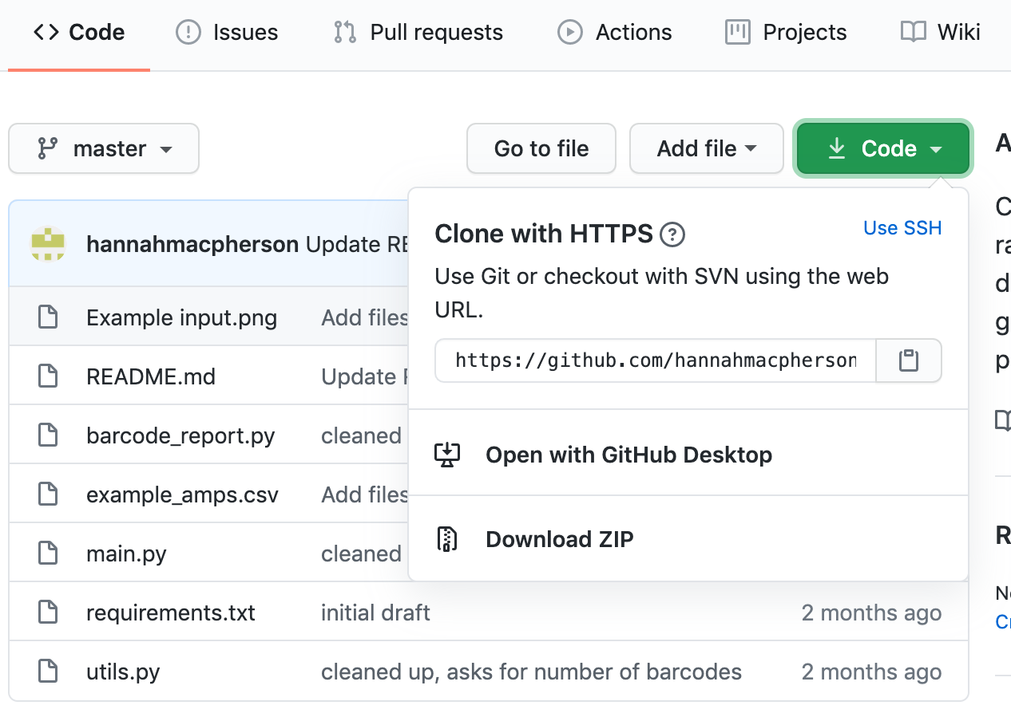

1. Unzip the folder and put it in your Documents (I renamed mine 'barcode_evaluator_script')

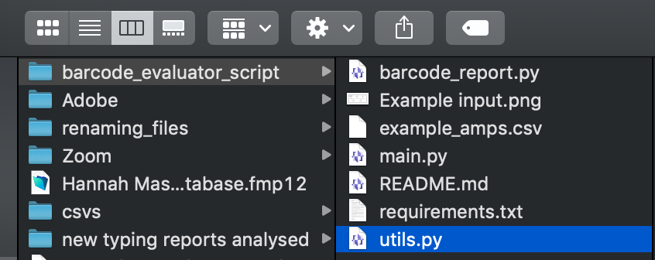

1. Navigate to the folder in Terminal and download the required packages

Navigation: 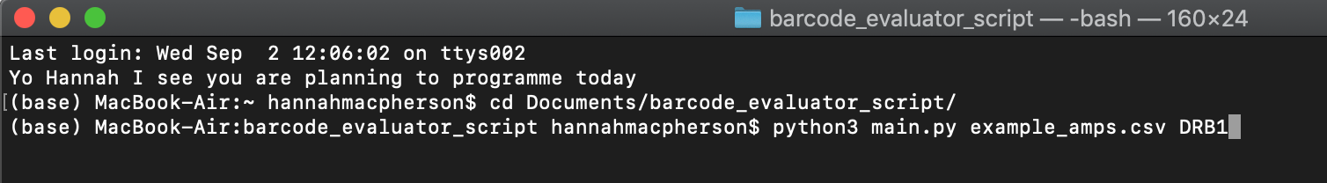 Downloading packages: 

It can be a little slow but you should see something like this (may vary if you have used other scripts on your machine previously):

**What to do to run the script each time from now on:**

1. Put your input CSV file in the barcode evaluator folder. Navigate to this folder in terminal (line 3) and type in what you need from the script (line 4). More info on line 4 below:



1. The second line should be adapted in the following way:

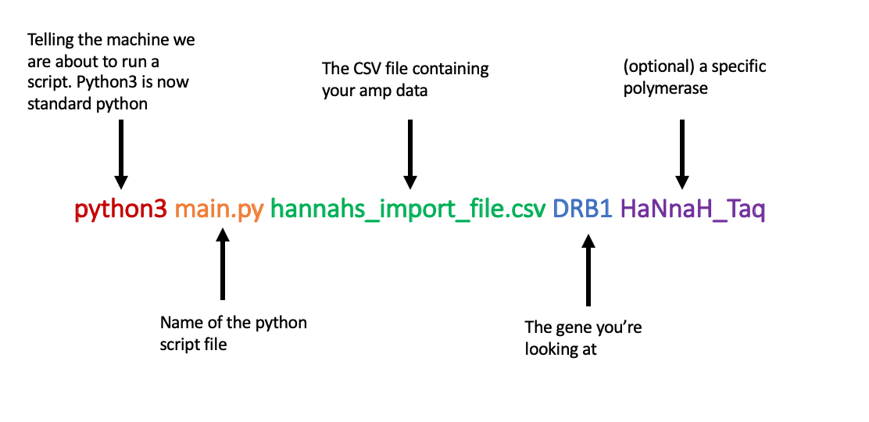

* Only change the last 3 parts, the first two remain constant
* NB **polymerase is optional**, if you don't write one then it will default to all data for that gene. Make sure you spell the gene and polymerase as they're written in your input file (case sensitive). You also **shouldn't have spaces within the gene or polymerase names**
* So for example, if I want to find the barcode success rates for DRB1 using a polymerase called HaNnaH_Taq, I would type:

python3 main.py hannahs_import_file.csv DRB1 HaNnaH_Taq

* If I want to find the barcode success rates for DRB1 using all the polymerases I've used in my input file, I would type:

python3 main.py hannahs_import_file.csv DRB1

1. You will be asked how many of the best/worst barcodes you want listed. It will then give you those, as well as the number of amplifications it is using and the mean number of amps per barcode. Obviously % success may be skewed by few uses, so keep an eye on what you’re putting in (and ideally use primers on a rotation to avoid this).

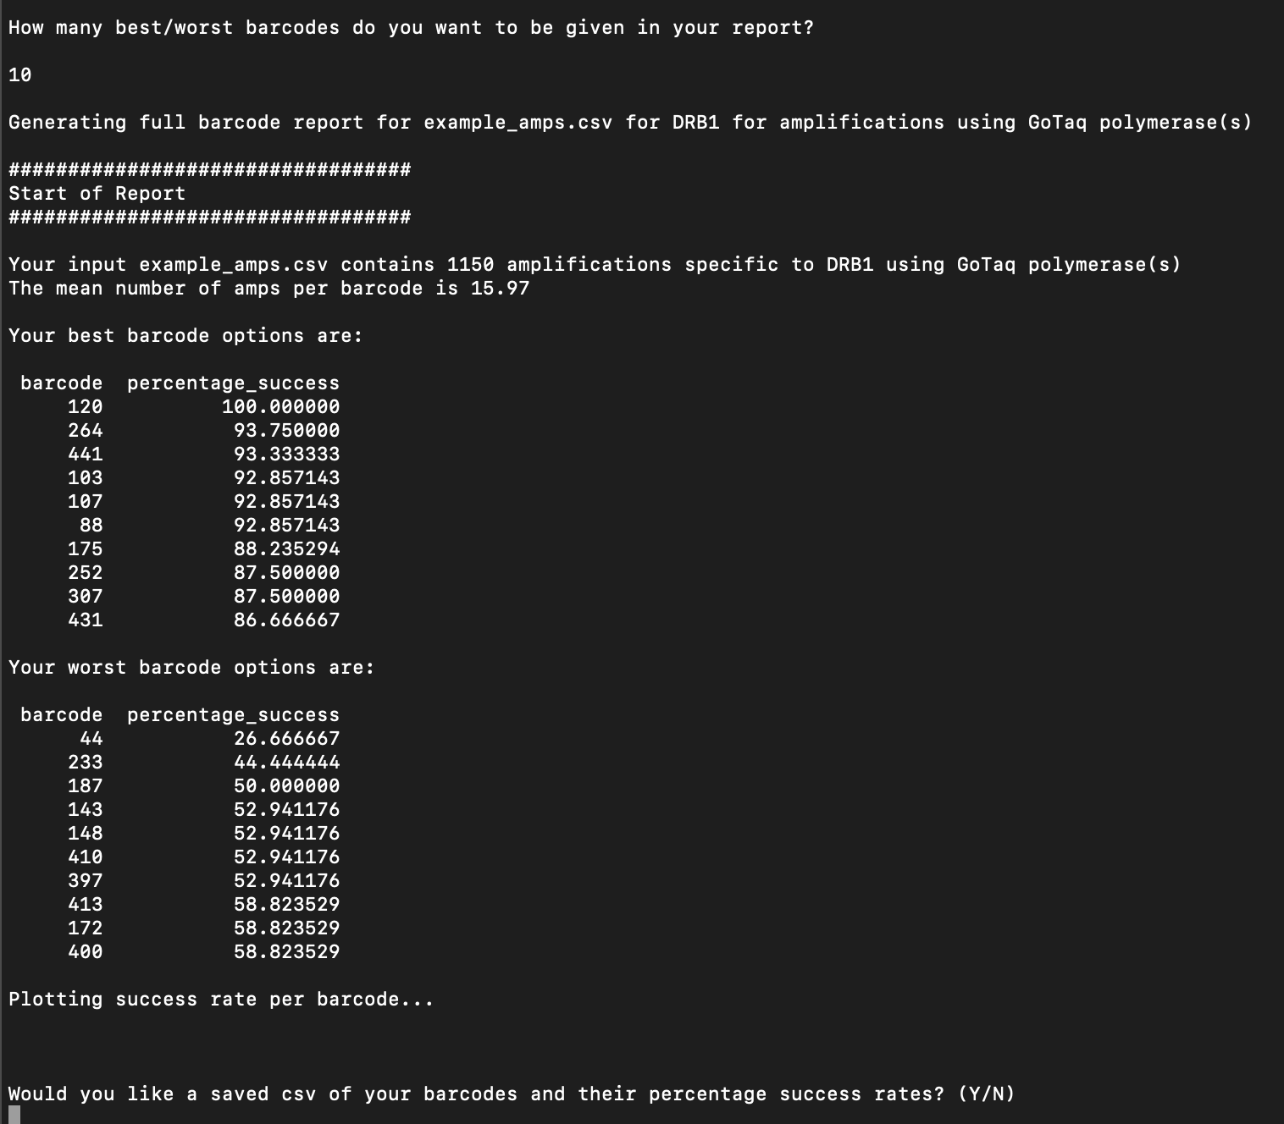

1. A graph will be plotted (example below). If you want to save it, do that within the pop-up.

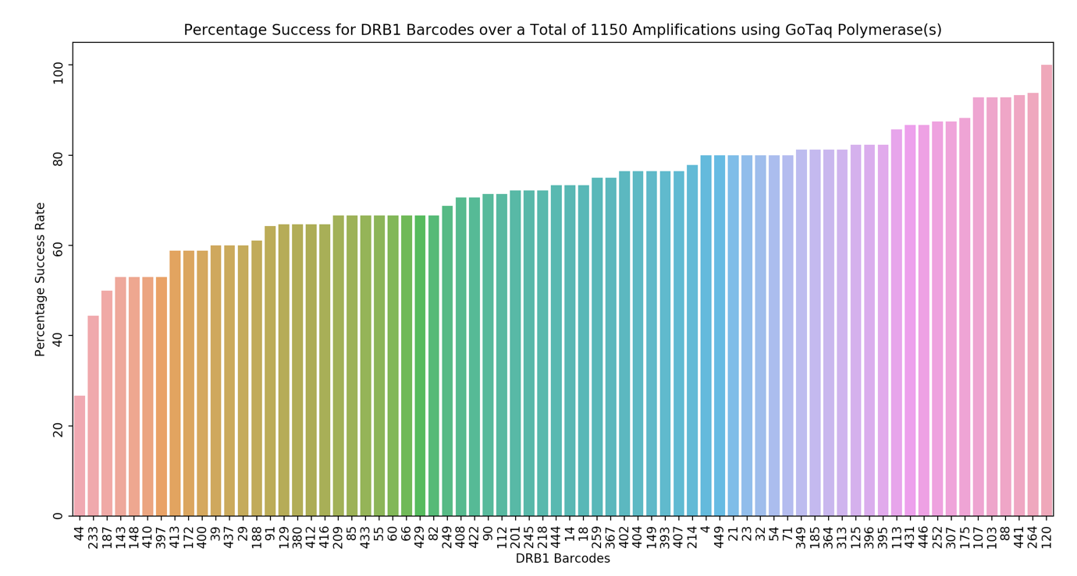

1. You'll be asked whether you want to save an additional CSV of every barcode the script has used and their % success rate (prompted to type Y or N). If yes, it will be saved within the same folder as your script.



Hannah

04/06/2020 (Script), 02/09/2020 (Instructions)